**The Winds of Boriken**

Senior Project  
Test Plan

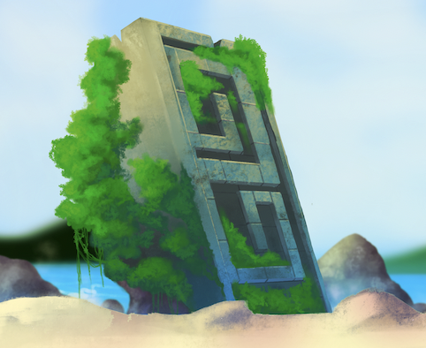

Paul Smith

psmith19@mail.stmarytx.edu

Spring 2022

**INTRODUCTION**

*The Winds of Boriken* is a 2D side scrolling beat ‘em up video game that takes place in a world inspired by the mythology of the Taino, the indigenous people of the Caribbean. Players move through the levels and defeat waves of enemies until they either reach the end or lose all of their health. The only intended platform is laptops and desktops, as the only control scheme is mouse and keyboard. Two players can play through the entire game on the same keyboard. While not all of the visual assets are finished and not all levels are fully fleshed out, all the core functionalities of the game have been created.

Throughout the test plan, there is a distinction between the actions ‘click’ and ‘press’. ‘Click’ is used to refer to left clicking with a mouse or touchpad. ‘Press’ refers to pushing down a key on the keyboard.

While all the functionalities listed below have been tested by me, there are likely multiple bugs that I am not aware of stemming from the large number of objects, some tightly coupled, interacting with one another. For example, each player character has a physical collider around their feet to prevent them from leaving the boundaries of the level. These colliders are turned into triggers that no longer collide with other physics objects when the player jumps or is knocked back. This prevents awkward collisions with the top-level boundary while the player is in the air. However, this means that it is possible for an enemy like the big shark to knock the player past a boundary they are not meant to cross and cause them to get stuck when they hit the ground. The individual functionalities, jump, boundary collisions, and getting knocked back, all function properly individually, but when put together in a certain case, become a problem. The layout of this test plan describes the expected results of individual player actions, but bugs like the one described above can only be found by thorough play testing of these actions with the rest of the game. The objective of this test plan is to test the former, the individual actions of the user, not explore every potential gameplay situation where they may be used.

For each major screen in the game, the player actions that can be taken and their expected results are listed. Some actions have notes giving more detail about the action and what proper functionality should look like. The last column is for testers to fill in.

**MAIN MENU**

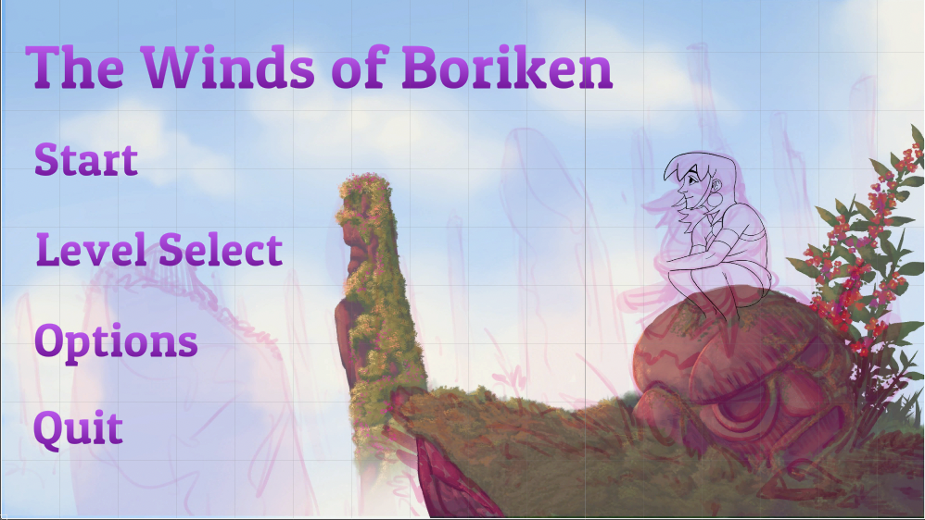

This is the first screen that players see when they load the game. While gameplay is controlled through the keyboard, all UI throughout the game can only be navigated through using a mouse.

| ACTION | EXPECTED RESULT | LIMITS/NOTES | Check/Problem/Notes |
| --- | --- | --- | --- |
| Click ‘Start’ | Load the tutorial scene |  |  |
| Click ‘Level Select’ | Open ‘Level Select’ screen |  |  |
| Click ‘Options’ | Open ‘Options’ screen |  |  |
| Click ‘Quit’ | Close application | Only if desktop build |  |

**OPTIONS**

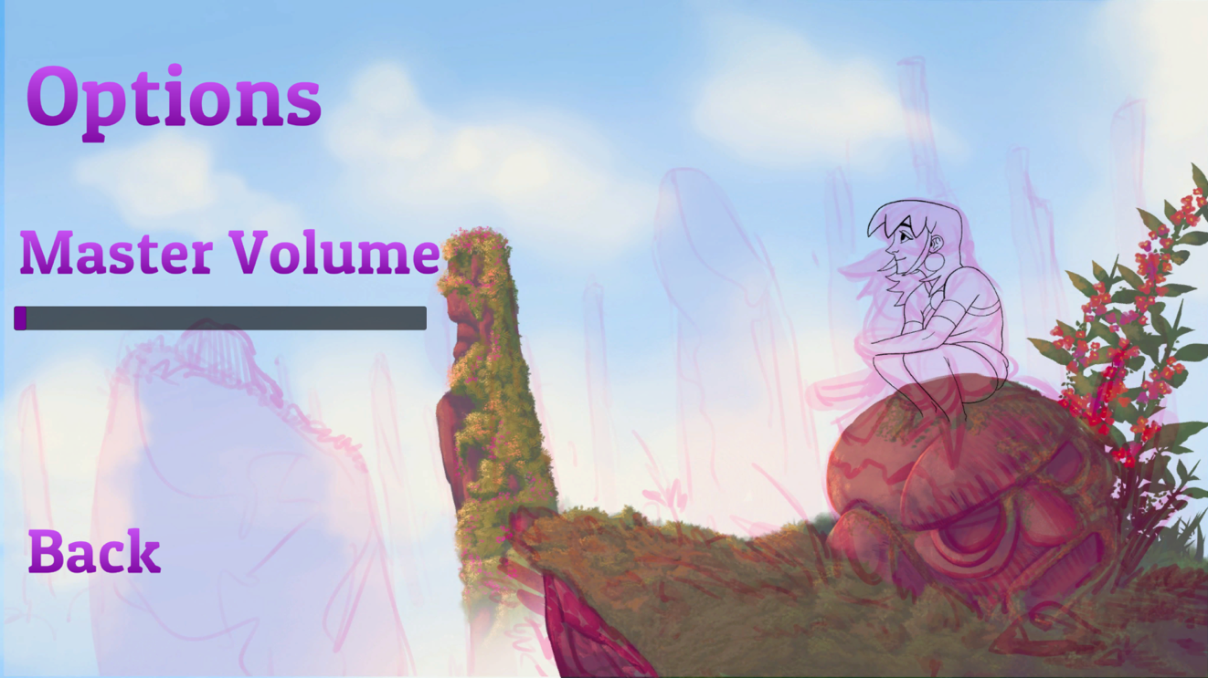

On this screen players can control the volume of all sounds and music throughout the game.

| ACTION | EXPECTED RESULT | LIMITS/NOTES | Check/Problem/Notes |
| --- | --- | --- | --- |
| Click ‘Back’ | Close options screen and go to main menu screen | The saving of settings is tied to the back button |  |
| Click and drag slider | Change master volume value in PlayerPrefs, and thus increase or decrease value of all sounds in the game. | Min volume is 0, max is 1. |  |

**LEVEL SELECT**

| ACTION | EXPECTED RESULT | LIMITS/NOTES | Check/Problem/Notes |
| --- | --- | --- | --- |
| Click ‘Tutorial’ | Load the tutorial scene | Should never be greyed out |  |
| Click ‘Bobagua’ | Load the Bobagua scene | Should never be greyed out |  |
| Click ‘Yara Colibri’ | Load the Yara Colibri scene if level unlocked | Should be greyed out if player has not yet completed Bobagua |  |
| Click ‘Cacibajagua’ | Load the Cacibajagua scene if level unlocked | Should be greyed out if player has not yet completed Yara Colibri |  |
| Click ‘Tureygua’ | Load the Tureygua scene if level unlocked | Should be greyed out if player has not yet completed Cacibagua |  |
| Click ‘Back’ | Close level select screen and go back to main menu |  |  |

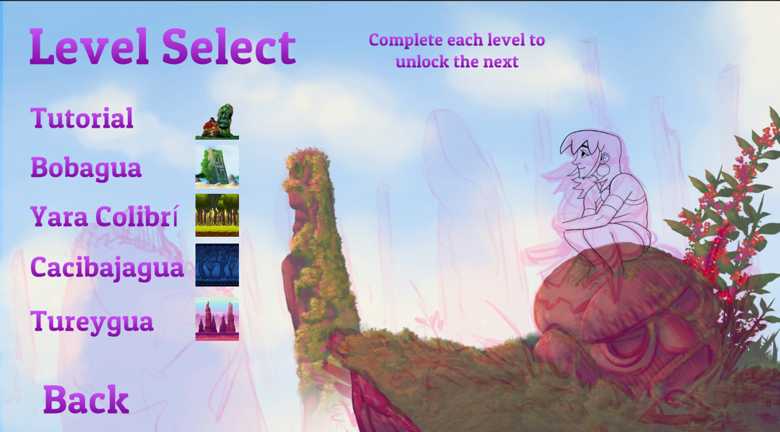

This screen is how players resume their progress by clicking on the level that they left off on.

**GAMEPLAY**

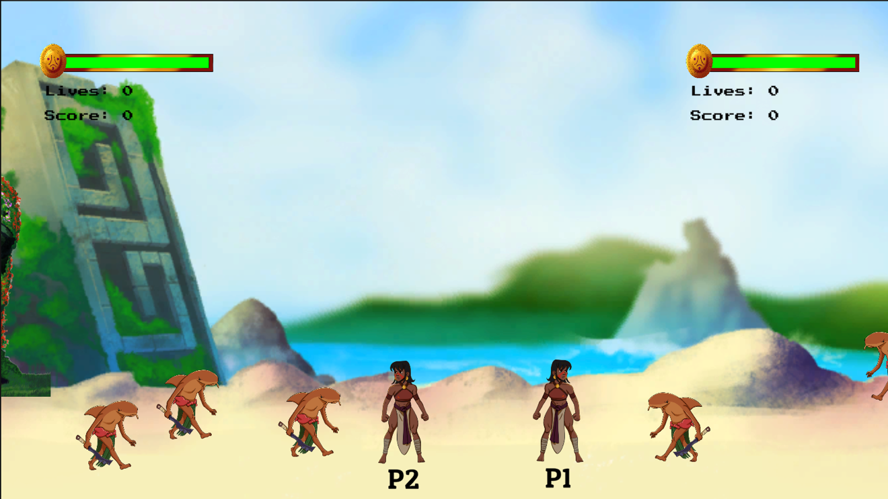

The primary way that players interact with the game is in the gameplay. Here is where players can move throughout the environment and defeat enemies with a combination of different sets of moves. When a second player is added, the screen will constantly resize to ensure both players are in frame, but I was unable to find a way to limit this resizing, meaning the camera can break outside the normal boundaries if players get to far apart. Also, because battle events lock the camera, players could potentially leave the camera awkwardly large should one leave the other behind and start a battle event. However, battle events are spaced out to make this situation unlikely. The actions below are listed for player one. All actions for player two are the same using the alternate control scheme shown on the controls screen.

| ACTION | EXPECTED RESULT | LIMITS/NOTES | Check/Problem/Notes |
| --- | --- | --- | --- |
| Press ‘W’ | Move the player up | Moving diagonally next to the top boundary collider slows the movement of the player |  |
| Press ‘A’ | Move the player to the left |  |  |
| Press ‘S’ | Move the player down | Moving diagonally towards the bottom boundary collider slows the movement of the player |  |
| Press ‘D’ | Move the player to the right |  |  |
| Press ‘Space’ | Make the player character jump | Currently jumping turns the player’s collider into a trigger to allow the player to jump when standing at the upper boundary collider |  |
| Press ‘Left ctrl’ | Trigger attack animation and deal damage to enemies in range. Can also be done while jumping or grabbing an enemy. | Most enemies will be interrupted by player attacks, but not all of them. |  |
| Press ‘Shift’ | Grab/throw enemies. Enemies that are grabbed should not be able to break free unless the enemy is thrown, loses all its health from grab attacks, or the player is attacked by another enemy. | Only triggers grab animation if an enemy is in range to be grabbed. Only one should be grabbed. Enemies can be thrown into other enemies, though some enemies, like the big shark, will not be knocked down by this. |  |
| Press ‘E’ | Pickup items or replay dialogue | Item pickups should only give health/score to the player who picked them up |  |
| Press ‘Esc’ | Pause the game |  |  |

**PAUSE MENU**

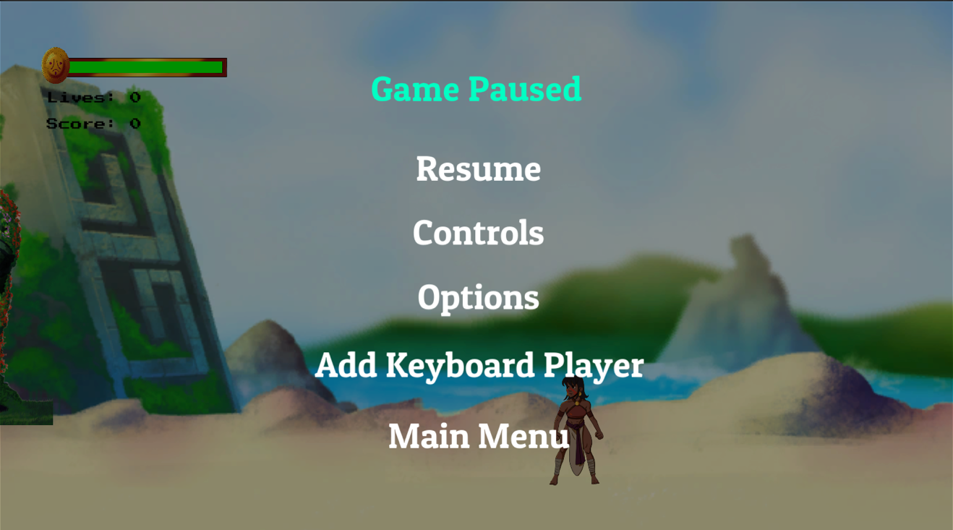

Players can pause the game at any time and freeze the timescale of the game, causing everything to freeze in place and refrain from updating. Like the main menu, the UI can only be navigated by clicking on buttons with the mouse. The pause menu can only be closed by pressing the “Resume” button, pressing the pause button again will not resume the game.

| ACTION | EXPECTED RESULT | LIMITS/NOTES | Check/Problem/Notes |
| --- | --- | --- | --- |
| Click resume | Resume the game and reset the timescale. | This button is the only way to resume the game |  |
| Click controls | Go to the controls screen |  |  |
| Click options | Go to the options screen | Moving diagonally towards the bottom boundary collider slows the movement of the player |  |
| Click add keyboard player | Add a second player that is controlled on the same keyboard | Turns to “Remove Keyboard Player” after being pressed. Player two will always be spawned with a score of zero and full health. |  |
| Click remove keyboard player | Remove player two and all their associated UI elements | Turns back to “Add Keyboard Player”. |  |
| Click main menu | Go back to the main menu | The player’s progress through the level will not be saved. |  |

**PAUSE MENU – OPTIONS**

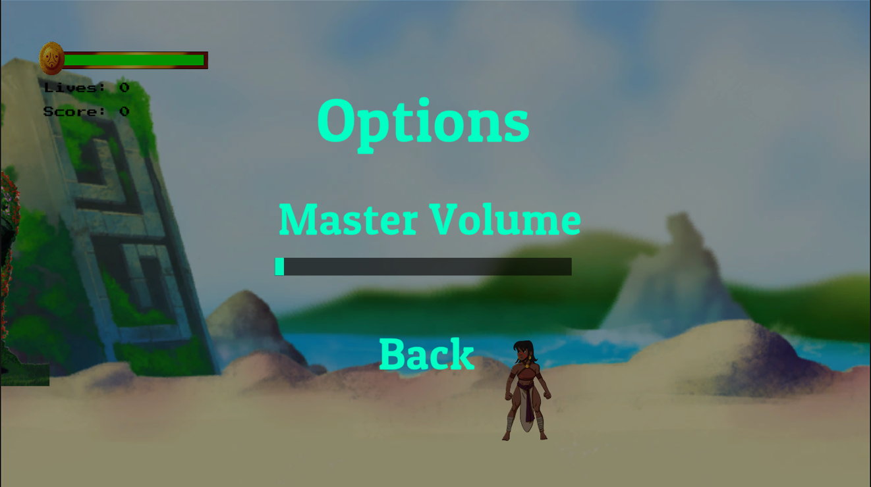

The options screen within the is functionally equivalent to the options screen in the main menu, and volume set in one screen should match the volume seen in the other.

| ACTION | EXPECTED RESULT | LIMITS/NOTES | Check/Problem/Notes |
| --- | --- | --- | --- |
| Click ‘Back’ | Close options screen and go to main menu screen | The saving of settings is tied to the back button |  |
| Click and drag slider | Change master volume value in PlayerPrefs, and thus increase or decrease value of all sounds in the game. | Min volume is 0, max is 1. |  |

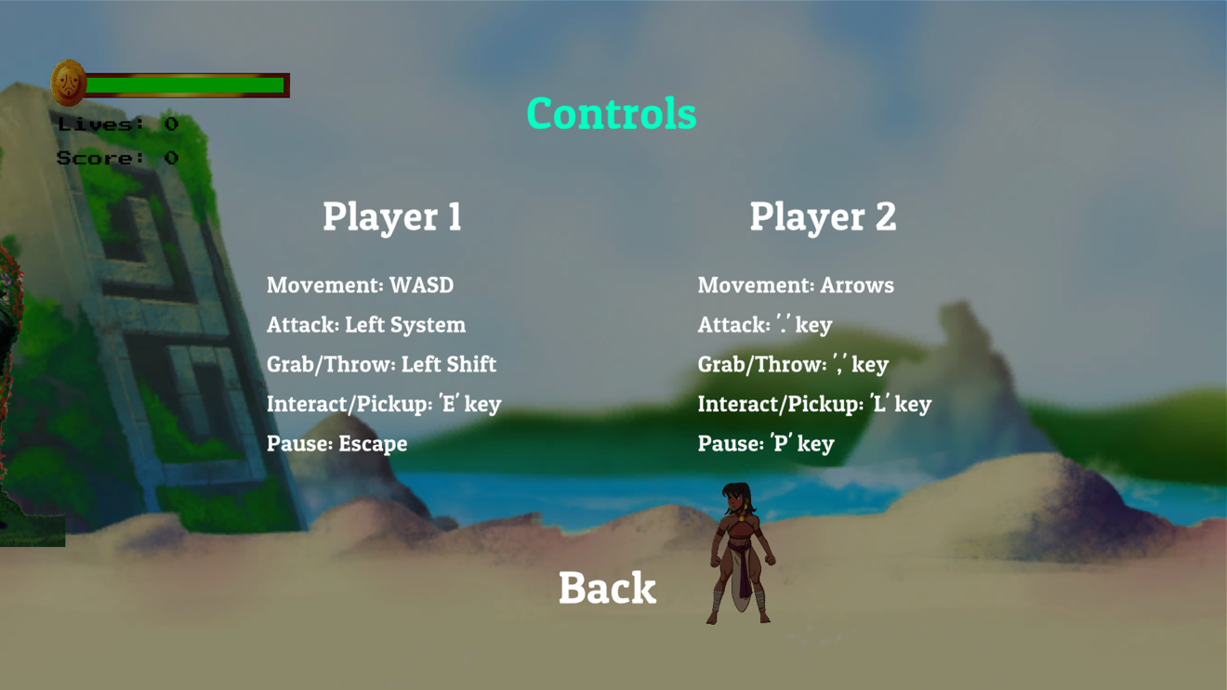**PAUSE MENU - CONTROLS**

There is no functionality on this screen other than the back button.

| ACTION | EXPECTED RESULT | LIMITS/NOTES | Check/Problem/Notes |
| --- | --- | --- | --- |
| Click ‘Back’ | Close ccontrols screen and go back to pause menu |  |  |

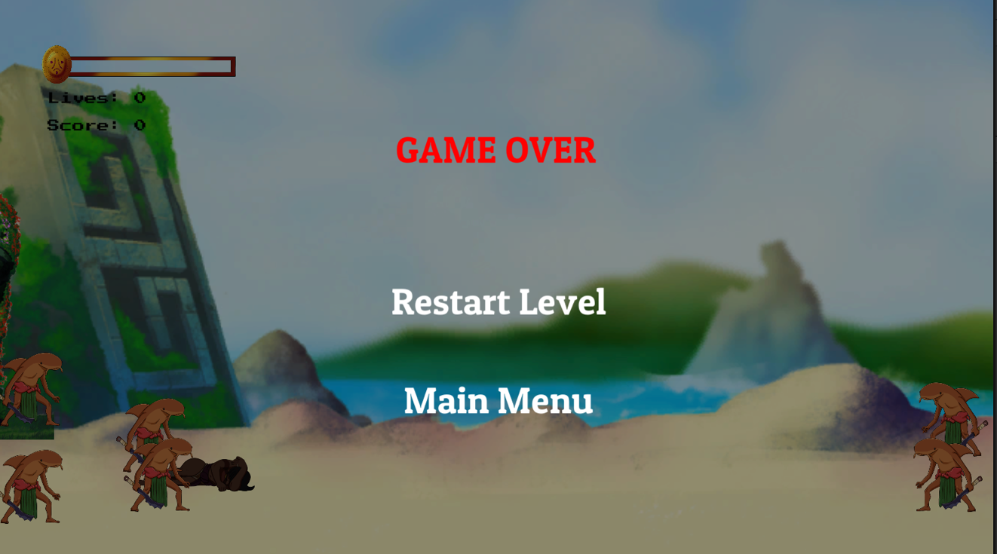**GAME OVER**

When this screen is reached, the game time does not freeze like with the pause menu, though all enemies are currently scripted to remain idle making the game look frozen.

| ACTION | EXPECTED RESULT | LIMITS/NOTES | Check/Problem/Notes |
| --- | --- | --- | --- |
| Click ‘Restart Level’ | Restart the current scene |  |  |
| Click ‘Main Menu’ | Go to the main menu |  |  |

**DIALOGUE**

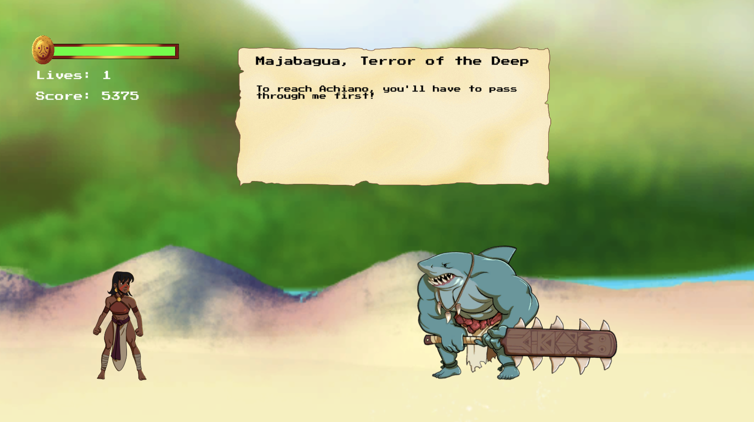

When in dialogue with NPCs, the only action available to the player is to move through the dialogue or pause the game. Because the dialogue box is implemented through the UI canvas, pausing the game is disabled to avoid overlap in the canvas.

| ACTION | EXPECTED RESULT | LIMITS/NOTES | Check/Problem/Notes |
| --- | --- | --- | --- |
| Press ‘Space’ or ‘left ctrl’ | Close options screen and go to main menu screen | The saving of settings is tied to the back button |  |

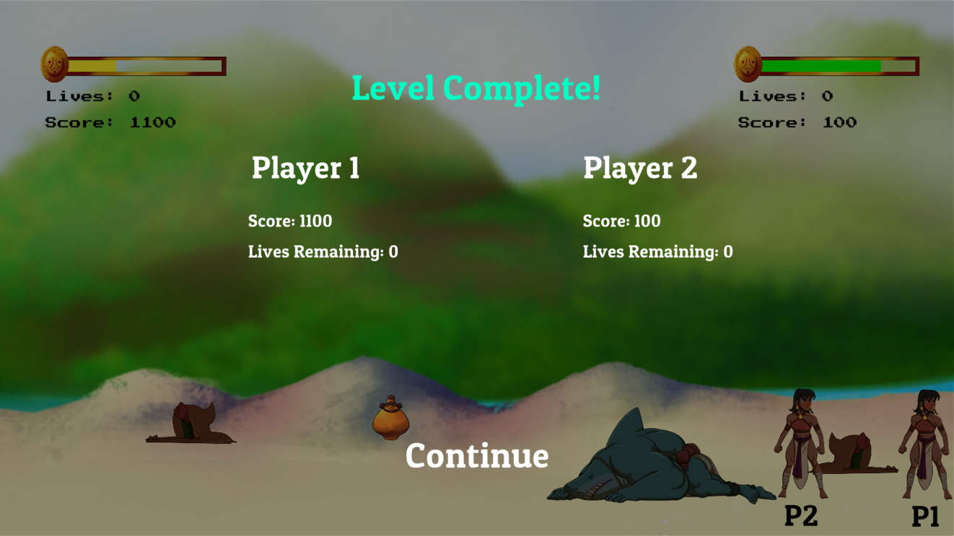 **LEVEL COMPLETE**

Currently players are forced to move on to the next level upon completion. If cooperative play is active, it will need to be restarted upon starting the next level, as there is currently no functionality for saving player states between scenes.

| ACTION | EXPECTED RESULT | LIMITS/NOTES | Check/Problem/Notes |
| --- | --- | --- | --- |
| Click ‘Continue’ | Go to the next level | Unlocks the next level in the level select screen |  |